TRƯỜNG THCS PHAN CÔNG HỚN
TỔ TIẾNG ANH - TIẾNG ANH 9
TUẦN 22 (TỪ 10/2 ĐẾN 15/2)
WEEK 22 - PERIOD 64-65-66
UNIT 5 : HEALTHY LIVING
REVIEW 2
Grammar
Rearrange the groups of words in the correct order to make complete sentences.
1. you need./a healthy diet/with all the nutrients/Doctors suggest eating
______________________________________________________________________________
2. Many people/them are dangerous./though some of/follow detox diets
______________________________________________________________________________
3. that children and teens/Experts suggest starting/school later so/get more sleep.
______________________________________________________________________________
4. doing exercise,/do it enough./people often don’t/are benefits to/Although there
______________________________________________________________________________
5. cutting out soda/We often suggest/losing weight./and chips/to start
______________________________________________________________________________
6. eating bananas,/Doctors suggest/to have a/yogurt, and fatty fish/healthy diet.
______________________________________________________________________________
7. their children./are risks/Though there/on the internet,/don’t monitor/many parents
______________________________________________________________________________
8. wants a/eat less/he doesn’t/want to/red meat./Although he/healthier diet,
______________________________________________________________________________
Pronunciation
a. Circle the word that differs from the other three in the position of primary stress in each of the following questions.
1. A. many B. obese C. diet D. access
2. A. calorie B. chemical C. bananas D. nutrients
b. Circle the word that has the underlined part pronounced differently from the others.
1. A. obese B. detox C. access D. sleep
2. A. virus B. nourishing C. risk D. addicted
Conversation
Choose the correct answer (A, B, C, or D).
1. Dr. Jones: “Although kids love using their phones, too much ____________ is bad for them.”
Mrs. Smith: “How much is OK?”
A. screen time B. fast food C. sleep D. fat
2. Mandy: “Drinking fruit juice is the same as eating fruit.”
Paul: “No, Mandy. That’s a ____________. Doctors suggest eating fruit, not drinking juice.”
A. myth B. detox C. risk D. nutrient

3. Chris: “I read that the sun makes our _______________strong.”
Leah: “That’s true. We should spend ten to thirty minutes a day in the sun.”
A. fat B. cafeteria C. virus D. bones
4. Mr. Green: “That’s all for today, everybody. ____________. You all worked very hard.”
Jack: “Thank you, Mr. Green.”
A. You didn’t do enough
B. Thanks for your time
C. Please open your books
D. Class starts in five minutes

PERIOD 65
UNIT 6: NATURAL WONDERS
LESSON 1-1 (New words)

- NEW WORDS:
1. accessible /əkˈsesəbl/ (a) : có thể tới được, dễ tiếp cận
2. formation /fɔːˈmeɪʃn/ (n) : sự hình thành, hình khối
3. mount /maʊnt/ (n) : núi, ngọn núi
4. outcrop /ˈaʊtkrɒp/ (n) : phần đất (đá) trồi lên
5. rainforest /ˈreɪnfɒrɪst/ (n) : rừng nhiệt đới
6. scenic /ˈsiːnɪk/ (a) : có cảnh đẹp thiên nhiên
7. spectacular /spekˈtækjələ(r)/ (a) : đẹp mắt, ngoạn mục
8. summit /ˈsʌmɪt/ (n) : đỉnh, điểm cao nhất
- Write the suitable word for each picture

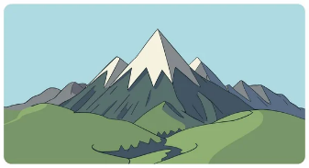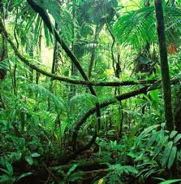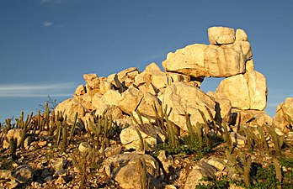
1._____________ 2. _______________ 3. _______________
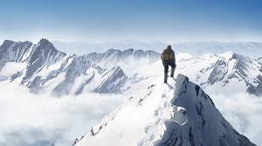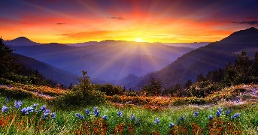
4._______________ 5.______________ 6._________________
III. Choose the word or phrase (A, B, C or D) that best fits the space in each sentence.
- In Sơn Đòong Cave, Water moving down for millions of years created amazing rock_______.
- Formations B. spectaculars C. landscapes D. rainforests
- The water running through the cave created the rocky___________.
A. summit B. outcrops C. rangers D. government
- I climbed all the way to the ______of Mount Snowdon. There was a great view from the top.
A. beach B. formation C. summit D. nature
- So many animals live in the_________________.
A. ranger B. formation C. wild D. rainforest
- Bat Cave is beautiful but not as_____________as Deer Cave.
- sandy B. wonderful C. attractive D. accessible
- I think ________ Son Tra is as more scenic than other mountains.
A. ranger B. Mount C. wild D. rainforest
- The sunset was a ____________ sight, with beautiful colors filling the sky.
- spectaculars B. rainforests C. landscapes D. Formations
- Joe is excited to sail among many _______ limestone island in Ha Long Bay.
A. rangers B. scenic C. summits D. rainforest

PERIOD 66
UNIT 6: NATURAL WONDERS
LESSON 1-2 (Grammar)
- Comparative structures with intensifiers:

- (not) as….as :

(+) S + is/am/are + as + adjective + as…….
(-) S + isn’t /am not /aren’t + as + adjective + as…….
Ex: I think Nha Trang is as beautiful as Mui Ne
Son Doong Cave isn’t as accessible as En Cave.
- Intensifiers (a bit /far /much):

* Để nhấn mạnh so sánh:
+ adj -er
S + is/am/are + far /much + than…….
+ more + adj

Ex: I think Ha Long bay is much more beautiful than Mui Ne Beach.
Mount Fansipan is far higher than Mount Langbian.

* Để làm dịu sự so sánh:
+ adj -er
S + is/am/are + a bit + than……
+ more + adj
Ex: I think Mang Den in Kon Tum is a bit more peaceful than Da Lat.

- Irregular comparative adjectives:
good → better than
bad → worse than
far → farther than / further than

- Fill in the blanks with the correct form of the adjectives.
1. The view from the summit of Mount Fansipan is a bit __________________________than the view from Mount Langbiang. (beautiful)
2. The walk to the summit of the mountain is much __________________________than the walk through the forest to get to the beach. (scenic)
3. Ninh Bình is spectacular! I think the rocky outcrops there are much __________________________than the ones in Ha Long Bay. (interesting)
4. The rock formations in this cave are far __________________________than the photos online. (exciting)
5. Visiting the rainforest isn't as __________________________as visiting the beach. (relaxing)
6. The beach in Vũng Tàu is nice, but the one in Nha Trang is a bit _________________________. (clean)
7. I don't want to visit Son Doong Cave. I'd prefer to go somewhere that is much __________________ ____. (accessible)
8. This mountain is much __________________________than the other nearby mountains and hills. (tall)
9. Suối Tranh Waterfall isn't as __________________________as Bản Giốc Waterfall. (big)
- I think the beaches in Quy Nhon are a bit __________________________than any beaches in Vietnam. (spectacular)

